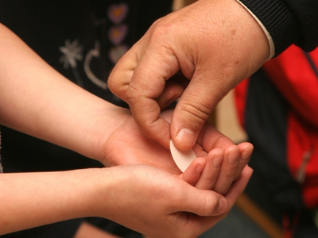
Communion in the Church Parking Lot on Sunday, May 24

- Participation in this opportunity is optional. The dispensation from the obligation to attend Sunday Mass is still in effect.
- Watch a Mass online or televised at your home Sunday morning.
- Drive to the Sacred Heart Parking Lot at 56 Throop Avenue to receive Communion in your car.
- Plan to arrive no earlier than 12 Noon.
- Enter the drive by the garages. Follow the direction of Volunteers in vests.
- Communion will be distributed from 12 Noon – 1:00 PM.
- Please remain in your car and follow directions of those assisting the priests.
- Consume the Sacred Host, then drive home in prayerful meditation.

Diocese of Metuchen Guidelines for Receiving Holy Communion while in a Vehicle
(For Temporary Use Only ordered by the Most Reverend Bishop)
Given the gradual easing of the New Jersey “Stay at Home” Order, the Diocese of Metuchen plans to offer its Faithful opportunities to receive Holy Communion. This decision is based upon prudential judgment and sound medical protocols to reduce risks and prevent the spread of the Coronavirus. The safety of parishioners, priests, deacons and extraordinary ministers of Holy Communion are of the utmost importance.
During a pandemic, many of our faithful are streaming the Mass online, or watching it on television, while making an act of a spiritual communion. However, this admirable practice, allowed when it is not possible to physically attend Mass, does not satisfy the inner-longing for the Sacramental Body of Christ. Beginning this weekend, Holy Communion will be distributed outside in parking lots at some local parishes following the offering of Holy Mass to the faithful who are in their cars, or in some cases people driving to church following the live streaming of Mass. Please check your local parish’s website (or call your parish) to see if this is happening at your parish. Every parish is not able to offer this for various reasons. The following protocols must be followed to ensure the safety of those who receive the Blessed Sacrament and those ministers who will provide it.
- These temporary protocols are for reception of Holly Communion while in a vehicle. It is important that the vehicle driver follow the instructions of its local parish.
- After reaching the designated area for the reception of the Eucharist, your vehicle should be placed into “park.”
- No one is permitted to exit the vehicle at any time according to the Governor’s executive order.
- The priest, deacon, or extraordinary minister of Holy Communion will approach your vehicle.
- The Minister of Holy Communion will approach wearing a mask and protective eye-ware.
- Anyone in the vehicle wearing a mask should remove it just prior to being approached to receive Holy Communion.
- Please do not engage in conversation with your minister. You will be less than 6 feet apart and you will not be wearing a mask prior to receiving Communion.
- Due to the pandemic and the challenges of distributing Holy Communion while the recipient is in a car, it is requested that Communicants receive in the hand. This is for your safety and the welfare of those who receive after you. The priest/minister will not deprive you of receiving on the tongue, should this be your decision, if they can do so safely. However, for the sake of the common good, everyone is asked to receive on the hand while receiving in the car.
- After you (and members in your vehicle) receive the Blessed Sacrament, please proceed forward to allow the next vehicle to approach.
- These guidelines will be re issued to reflect the best practices in compliance with executive orders when churches are allowed to reopen for public worship.

